4.1 Valid User Login
User should be able to access their dashboard based on their roles
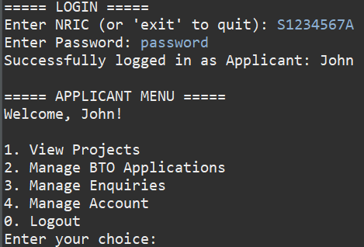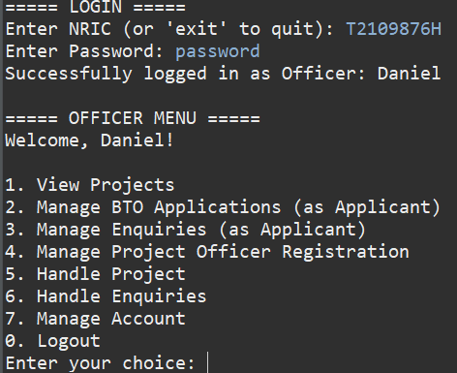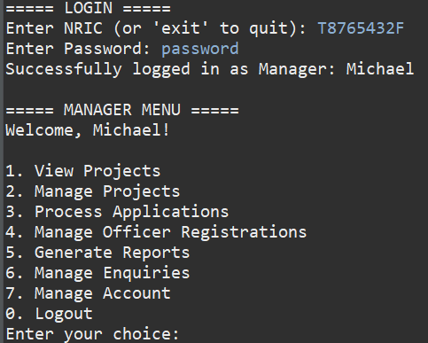

4.2 Invalid NRIC Format
User receives a notification about incorrect NRIC format
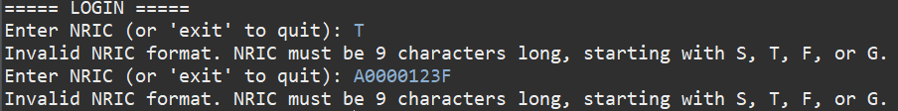

4.3 Incorrect Password
System should deny access and alert the user to incorrect password
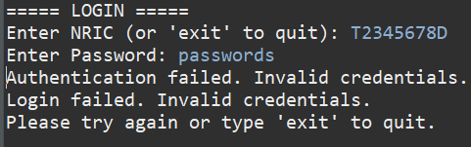

4.4 Password Change Functionality
System updates password, prompts re-login and allows login with new credentials

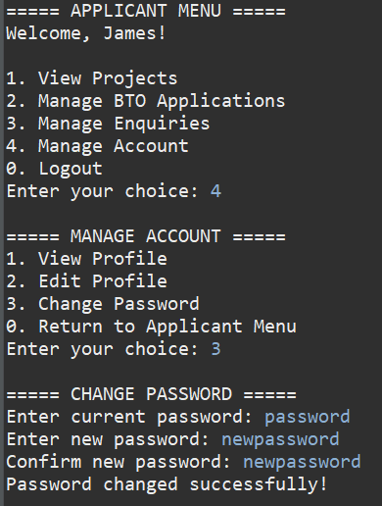
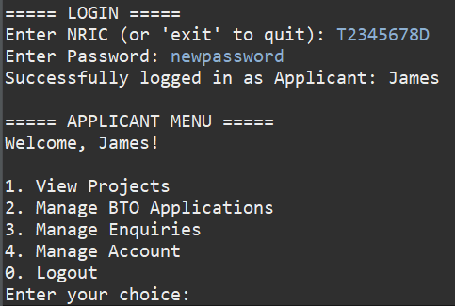

4.5 Project Visibility Based on User Group and Toggle
Projects are visible to users based on their age, marital status and the visibility setting

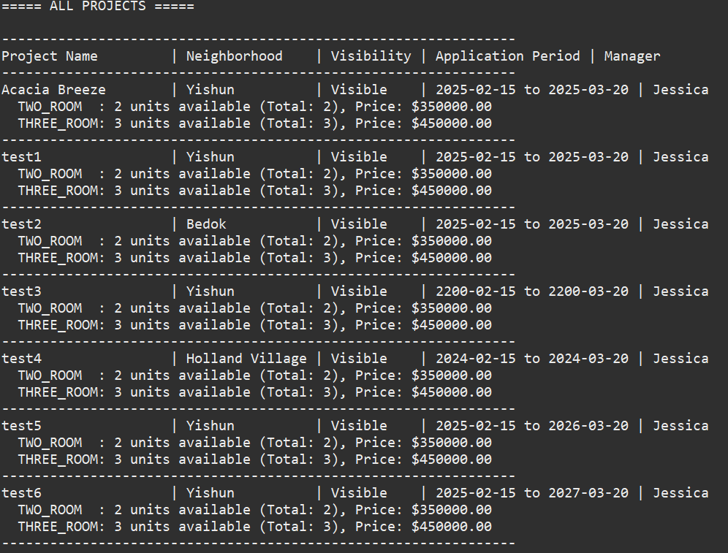
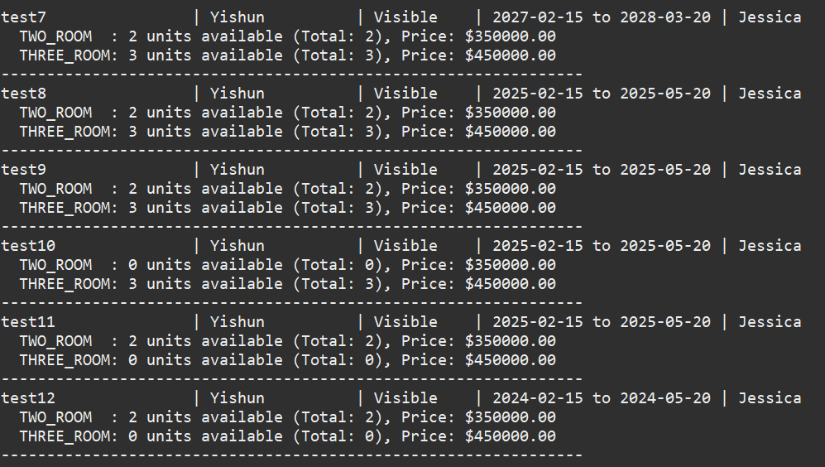
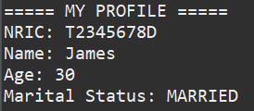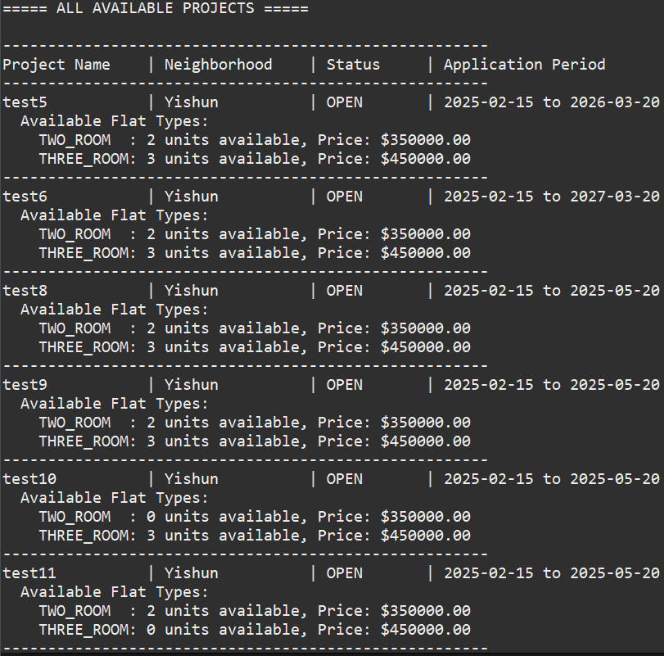
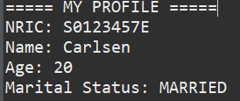
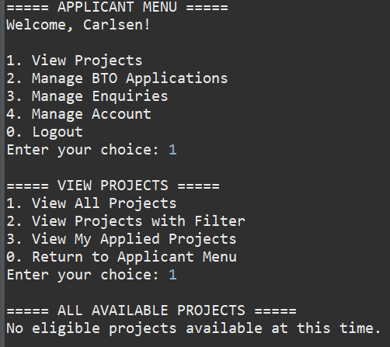
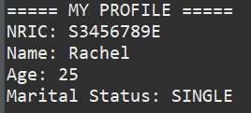
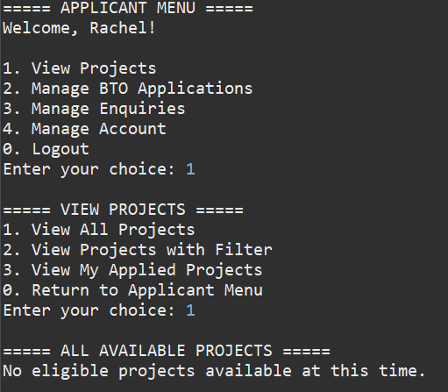

Based on visibility:
Manager (Jessica) toggled 2 open projects as “HIDDEN”:
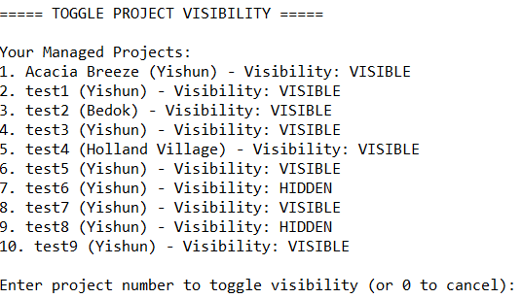
Applicant (John) cannot see the project visibility when he view all projects he is eligible to view for:
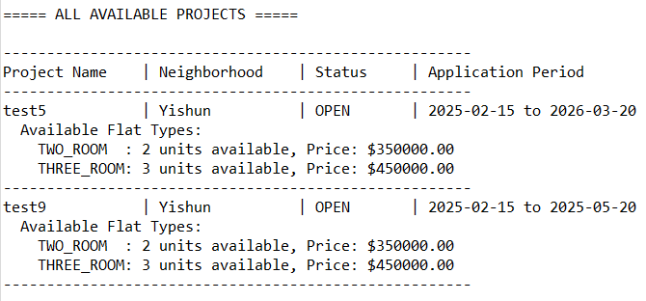

4.6 Project Application
Users can only apply for projects relevant to their group or when visibility is on
As per ProjectList.csv (which shows all the projects within the application):
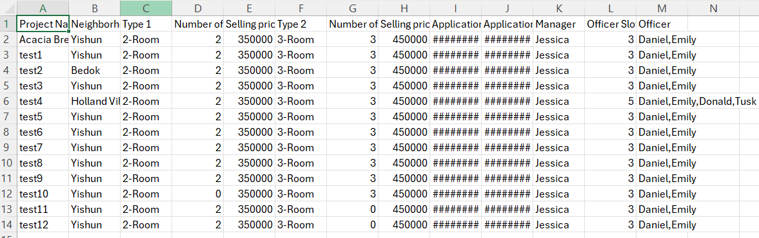
We can see that test10 has only 3-Rooms and no 2-Room. While test11 and test12 have only 2-Rooms and no 3-Room. This means as a Single person that is not 35 Years Old, they should not be able to apply for any project.

Applicant (Rachel) fits that criteria:

As seen, Applicant (Rachel) cannot apply for project:


Meanwhile, Applicant (John) fit the criteria to apply for 2-ROOM flats, as a Single 35 Year Old person:

As seen, Applicant (John) can apply for 2-Room project:
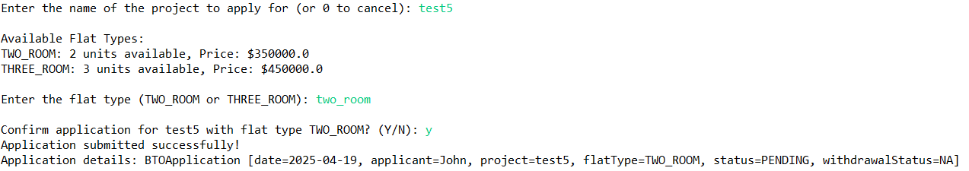
As seen, Applicant (John) can apply for 2-Room projects.

But he cannot apply for 3-Room projects:
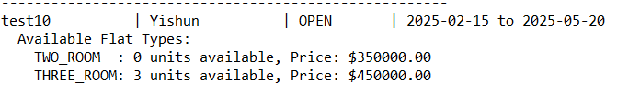
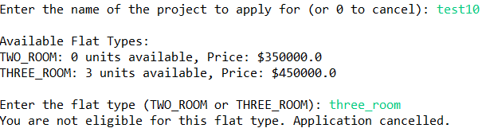

4.7 Viewing Application Status after Visibility Toggle Off
Applicants continue to have access to their application details regardless of project visibility

Applicant (John) applied for project “test8”:
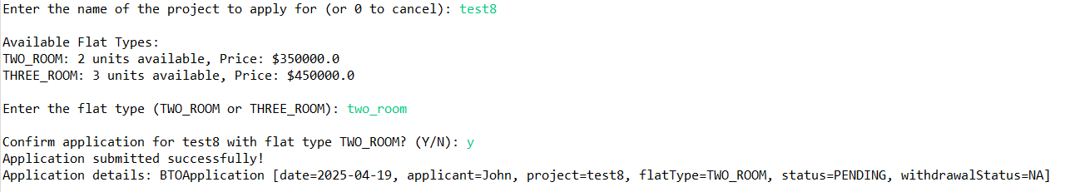
Manager-in-charge (Jessica) toggled the project visibility to be “Hidden”:
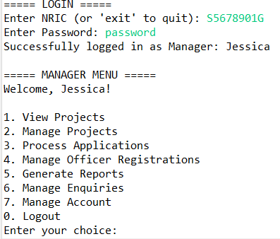
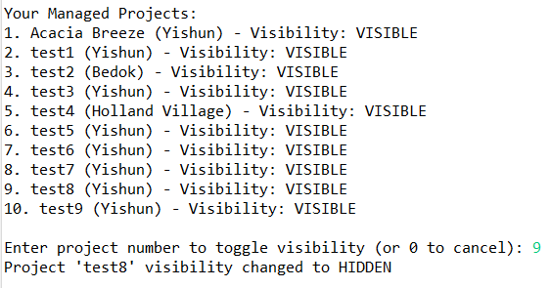
Applicant (John) is still able to see test8 when viewing his applied project:

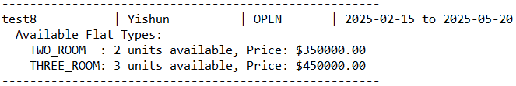

4.8 Single Flat Booking per Successful Application
System allows booking one flat and restricts further bookings
In this case, as from Test Case 4.6, the Applicant (John) has applied for test5. Manager-in-charge (Jessica) approved his project, so he can book an appointment:
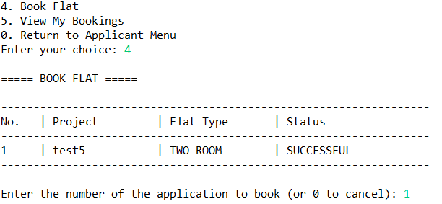
When trying to make a booking again, the Applicant (John) cannot make any further bookings:
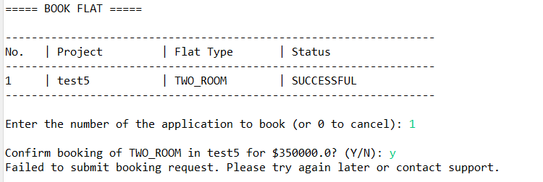

4.9 Applicant’s Enquiries Management
Enquiries can be successfully submitted, displayed, modified, and removed
Applicant (John) wants to submit a new enquiry for a VISIBLE project:
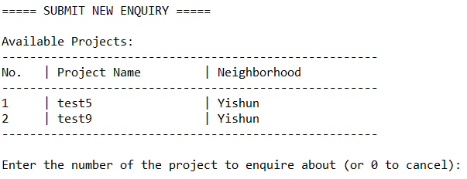
Submit an enquiry:
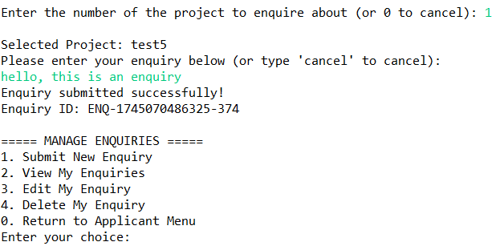
Display an enquiry:
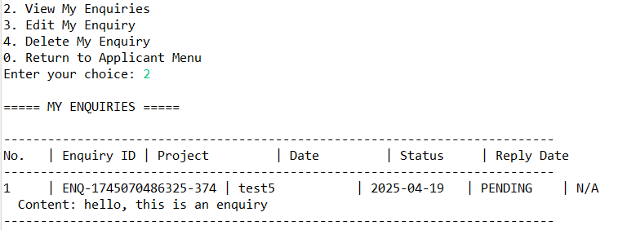

Modify an enquiry:
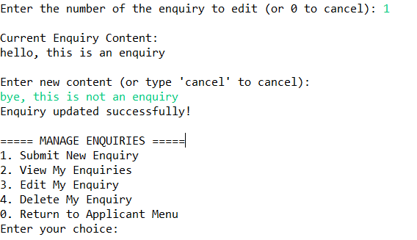
Modify an enquiry - enquiry modified successfully:
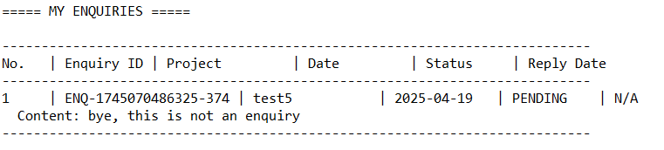
Remove an enquiry:
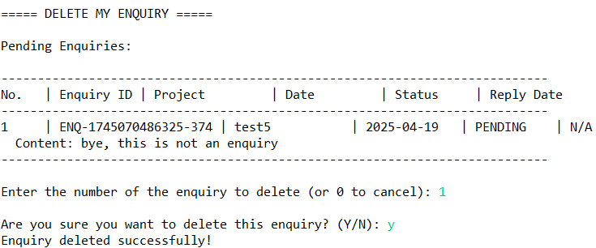
Remove Enquiry Sanity check - no enquiry is visible now since enquiry is deleted:
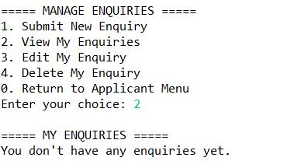

4.10 HDB Officer Registration Eligibility
System allows registration only under compliant conditions
Officer (Daniel) has been assigned the following projects:
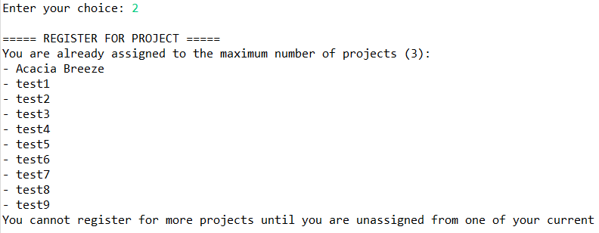
Based on this, he cannot register for any of these above projects as an applicant.
When trying to apply for a BTO project as an applicant, a warning appeared:
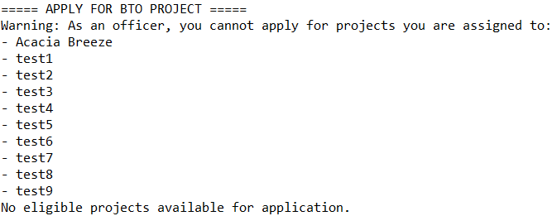
Another Officer (David) has the following projects assigned:
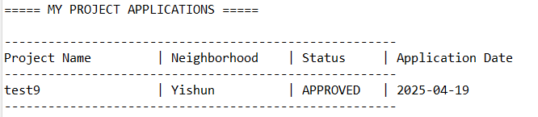
Hence, he cannot apply for any other open projects at this point in time:


4.11 HDB Officer Registration Status
Officers can view pending or approved status updates on their profiles

Officer (Test) applied to be part of an OPEN BTO project:
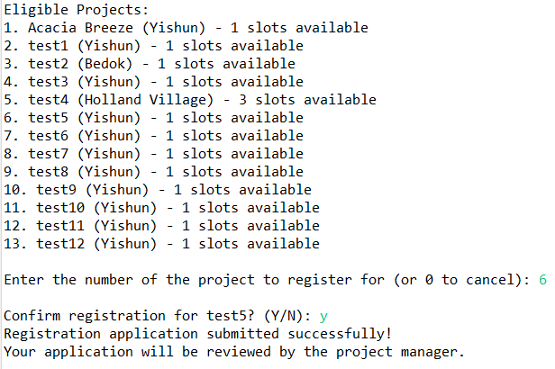
Officer (Test) can see his officer registration is pending:
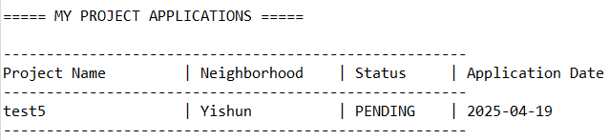

Manager-In-Charge (Jessica) approved Officer (Test) registration:
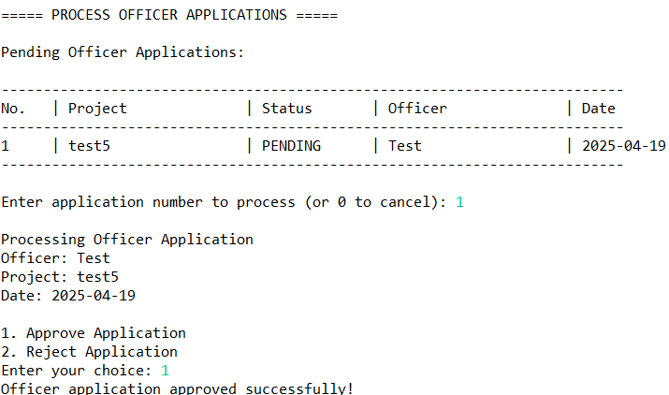

Officer (Test) can see his officer registration is approved:
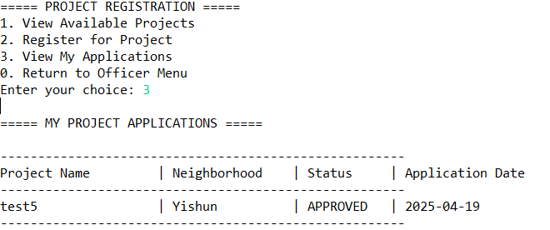

4.12 Project Detail Access for HDB Officer
Officers can always access full project details, even when visibility is turned off
Manager-in-Charge (Jessica) toggle test5’s visibility to be HIDDEN:
Officer-in-Charge (Test) can see the project test5, even when the project’s visibility is set to HIDDEN:
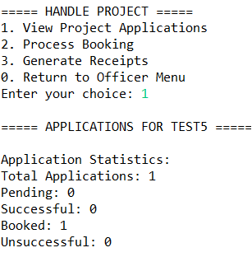

4.13 Restriction on Editing Project Details
Edit functionality is disabled or absent for HDB Officers
As an Officer-in-Charge (Test), he cannot edit the project under his charge:
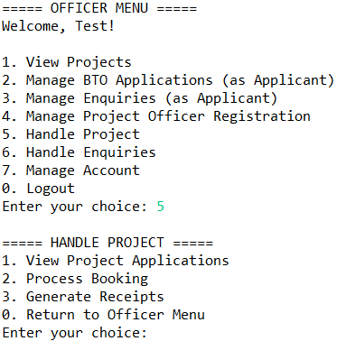
He can only handle enquiries, process booking and generate receipts.

4.14 Response to Project Enquiries
Officers and Managers can access and respond to enquiries efficiently
Applicant (John) submits an enquiry:
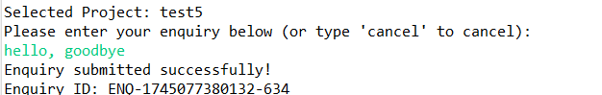
Officer-in-Charge (Test) can view the enquiry and respond:
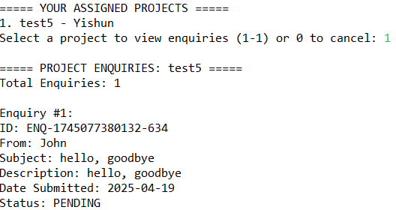
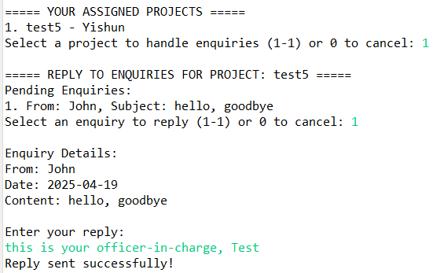

Applicant (John) submits another enquiry:
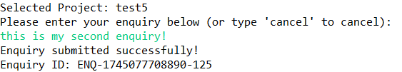

Similarly, Manager-in-Charge (Jessica) can also view the enquiry and respond:
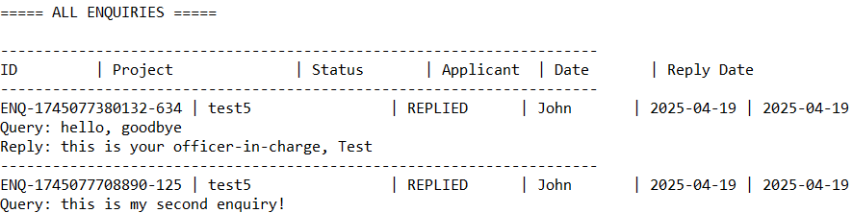
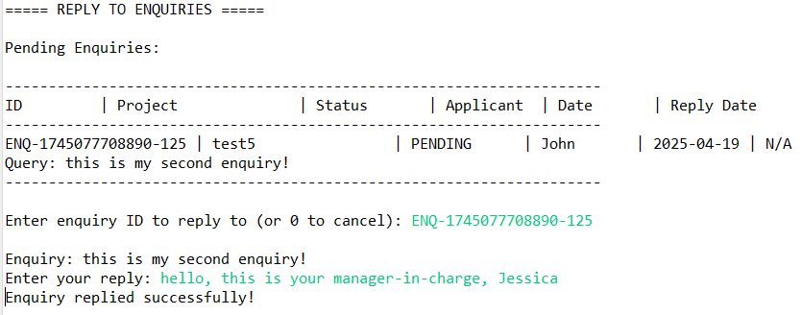

4.15 Flat Selection and Booking Management
Officers retrieve the correct application, update flat availability accurately, and correctly log booking details in the applicant’s profile

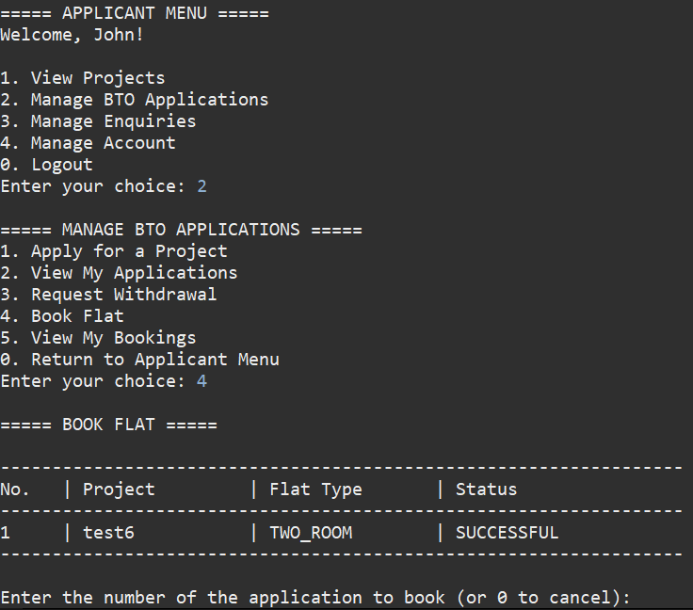
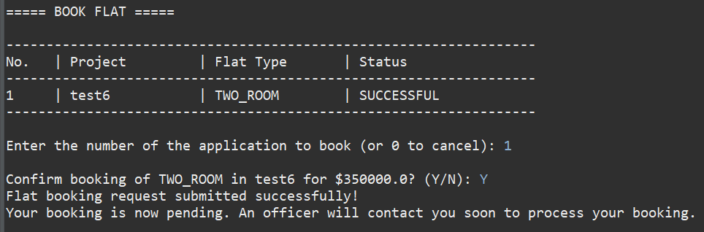

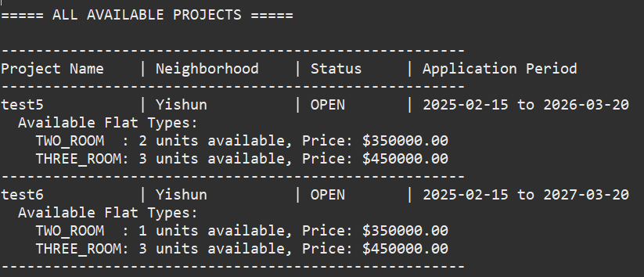

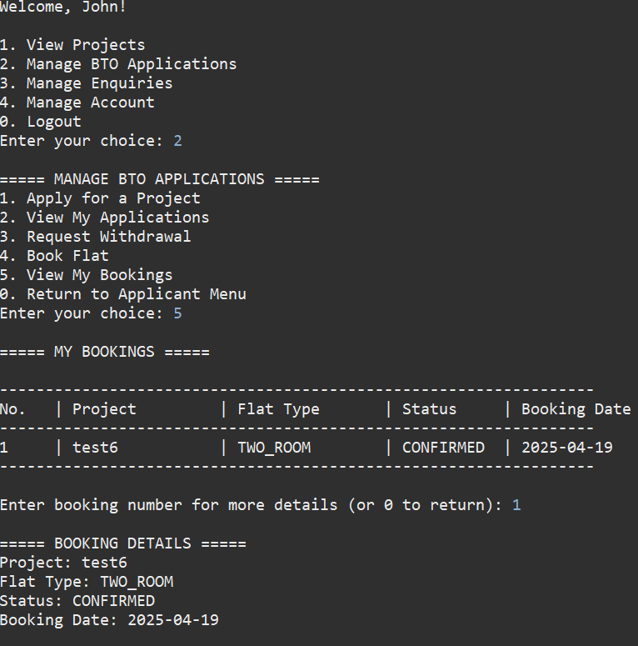
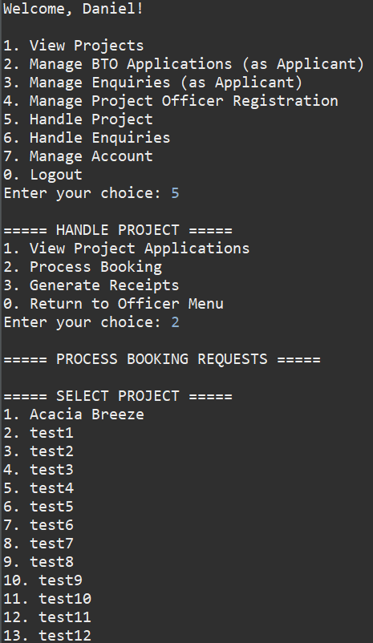
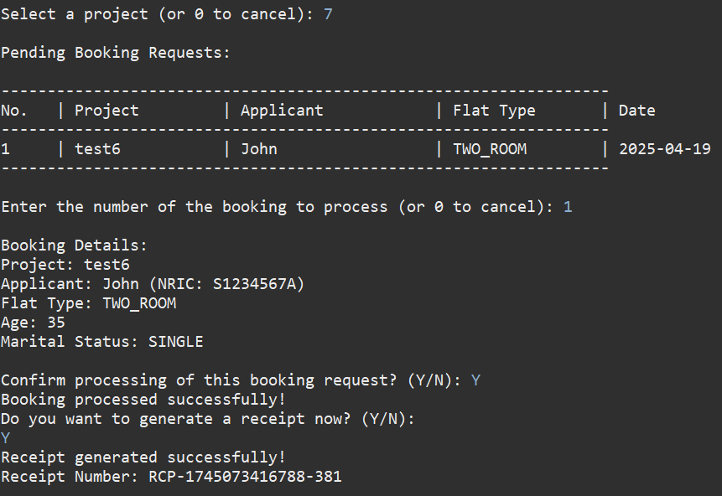

4.16 Receipt Generation for Flat Booking
Accurate and complete receipts are generated for each successful booking
Officer-in-charge (Emily) approved booking from Applicant (John) and generated a receipt for his booking:
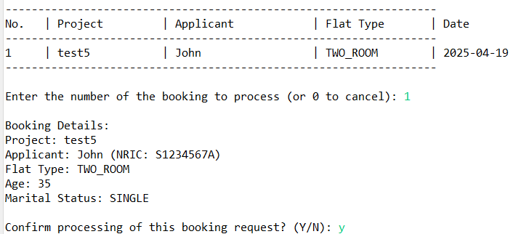
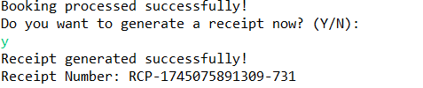
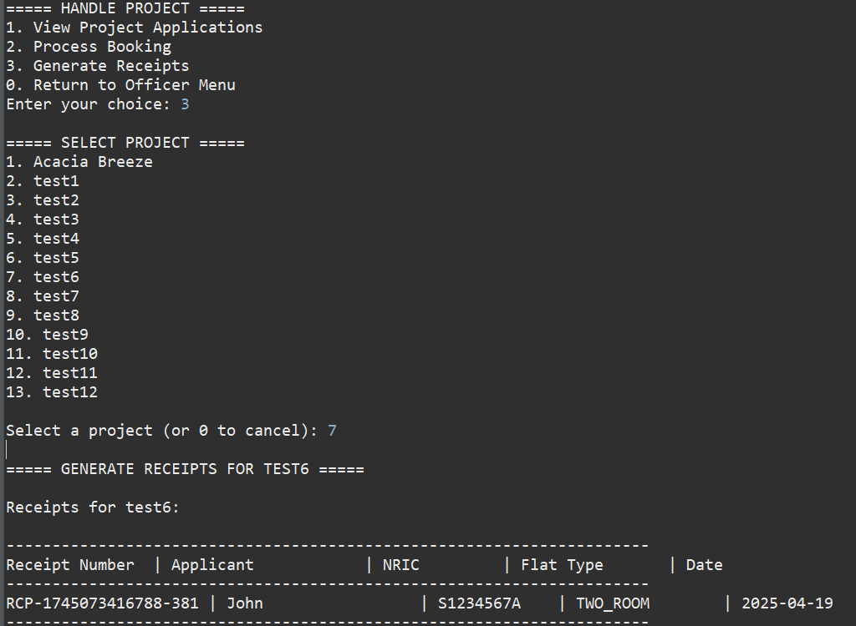

4.17 Create, Edit, and Delete BTO Project Listings
Managers should be able to add new projects, modify existing project details, and remove projects from the system
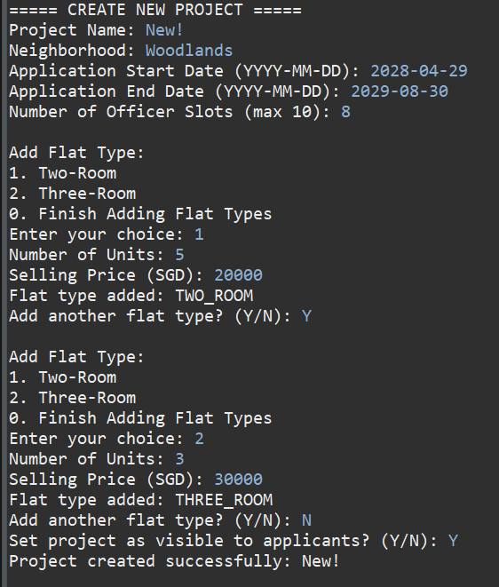

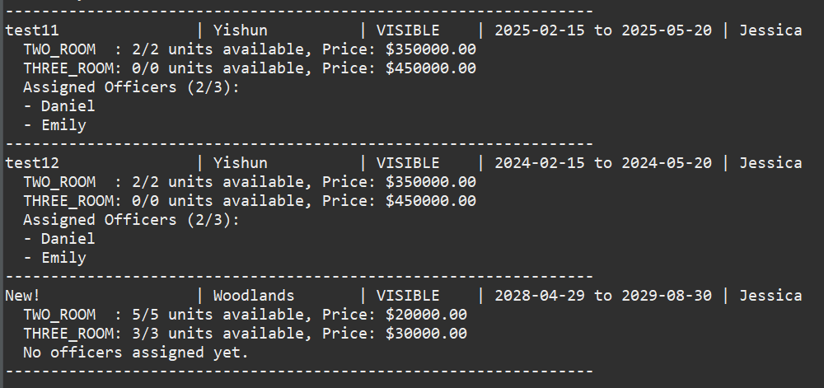

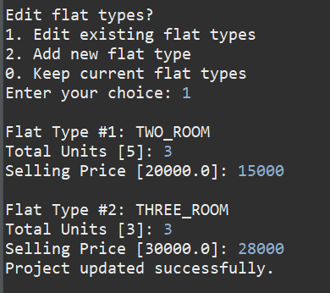
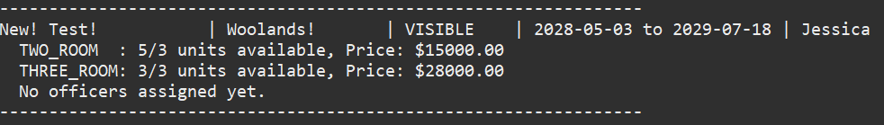

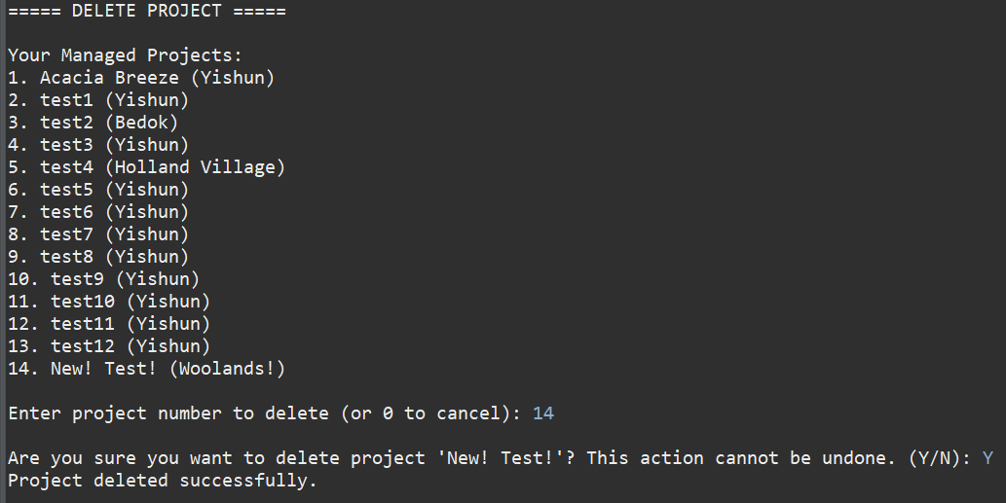
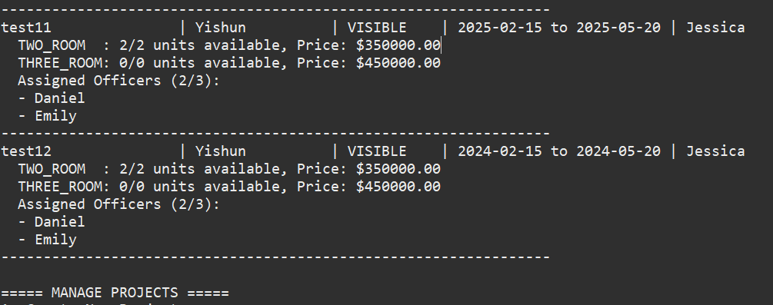

4.18 Single Project Management per Application Period
System prevents assignment of more than one project to a manager within the same application dates

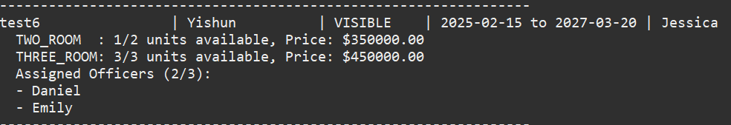
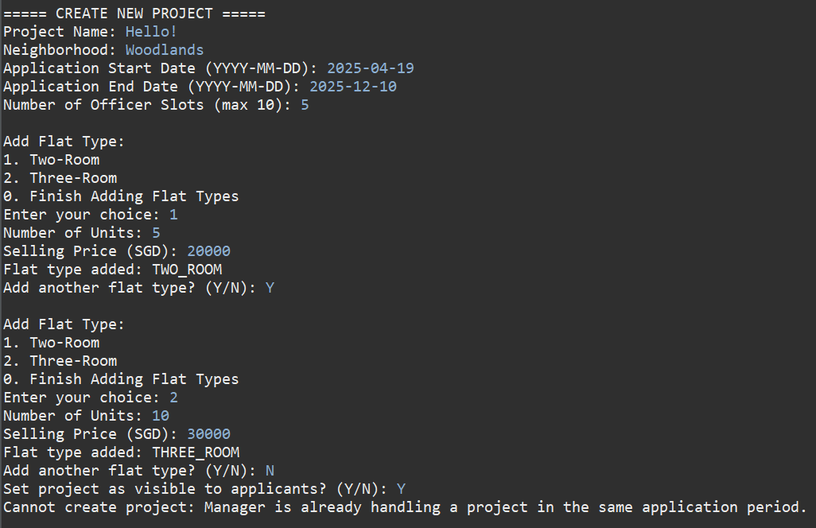

4.19 Toggle Project Visibility
Changes in visibility should be reflected accurately in the project list visible to applicants
Manager-in-charge (Jessica) toggled the project visibility to be “Hidden”:

4.20 View All and Filtered Project Listings
Managers should see all projects and be able to apply filters to narrow down to their own projects
0…
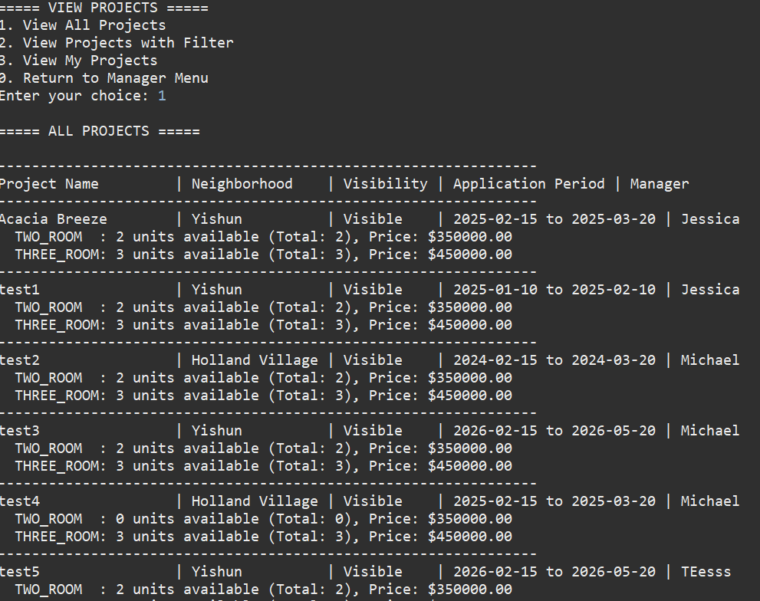

4.21 Manage HDB Officer Registrations
Managers handle officer registrations effectively, with system updates reflecting changes accurately
Manager-In-Charge (Jessica) approved Officer (Test) registration:

Officer (Test) can see his officer registration is approved:

4.22 Approve or Reject BTO Applications and Withdrawals
Approvals and rejections are processed correctly, with system updates to reflect the decision

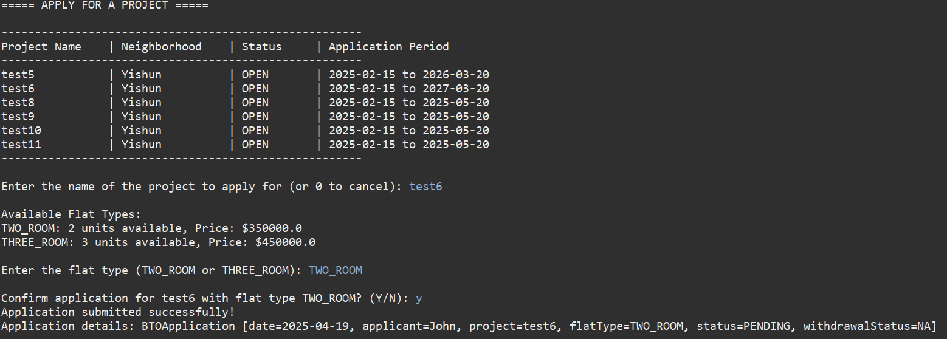
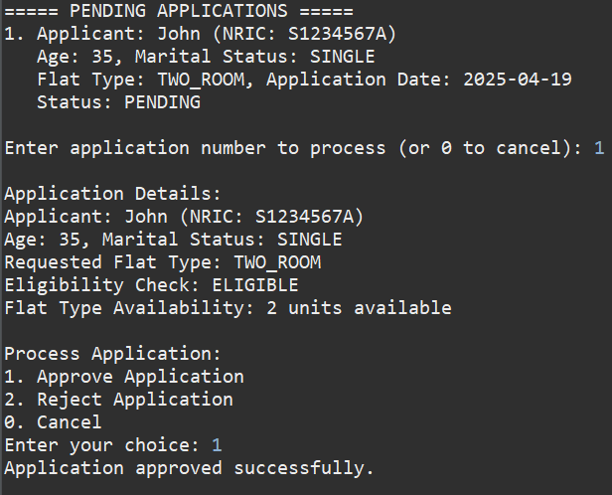
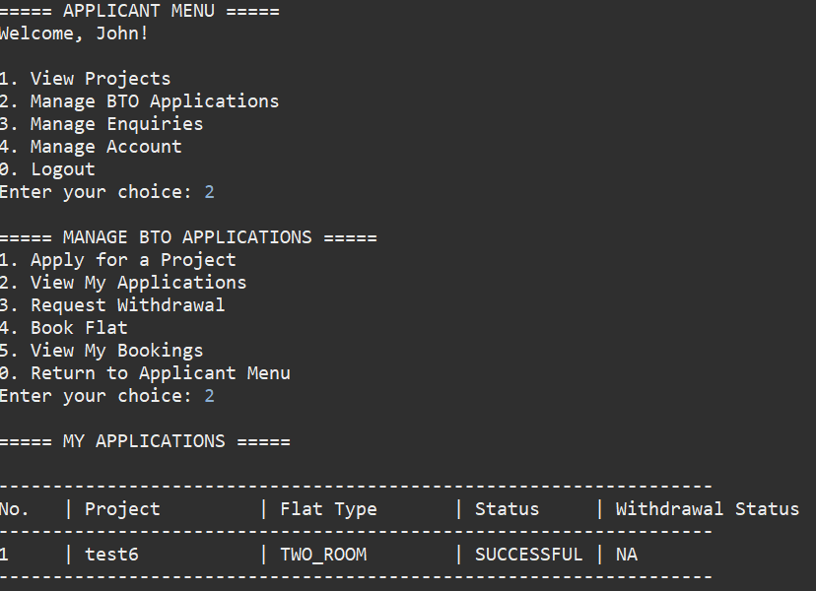
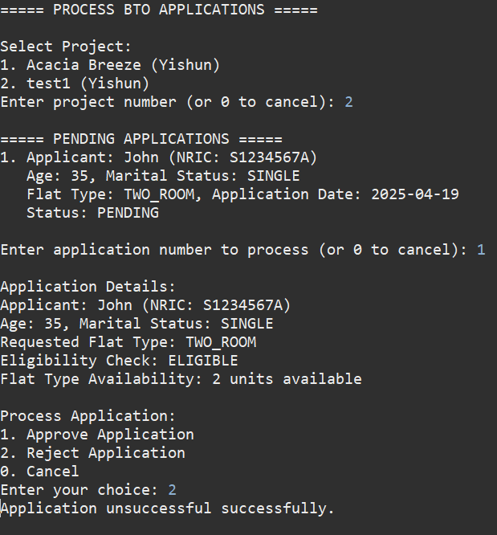

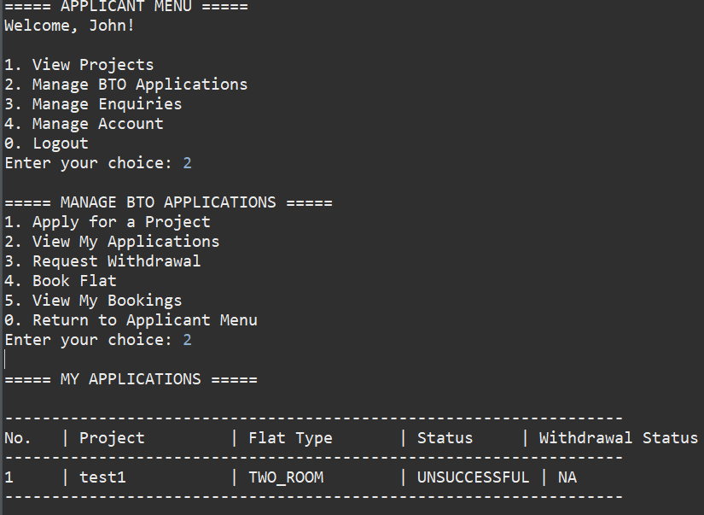

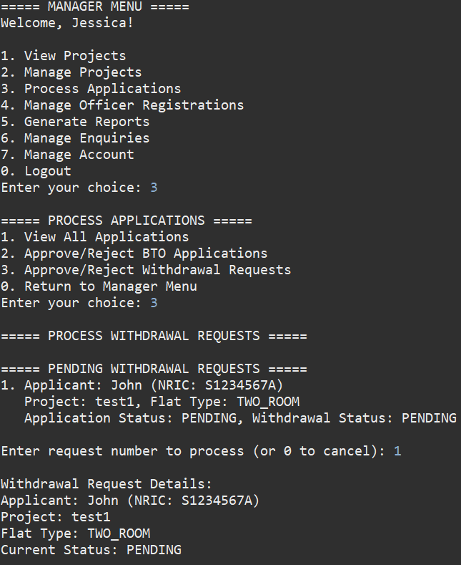
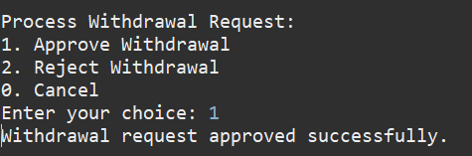
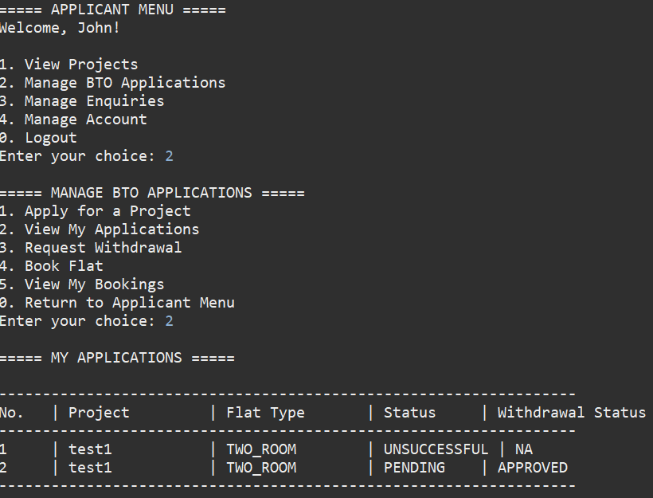

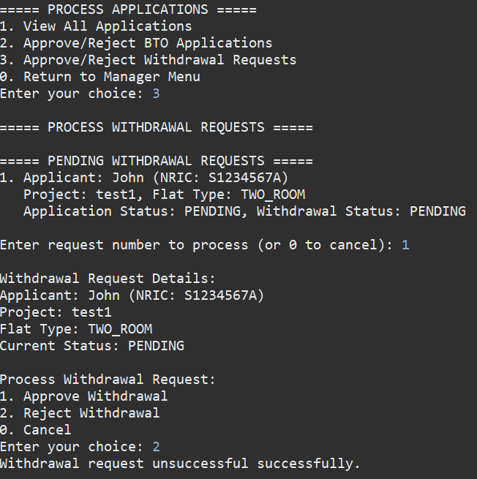

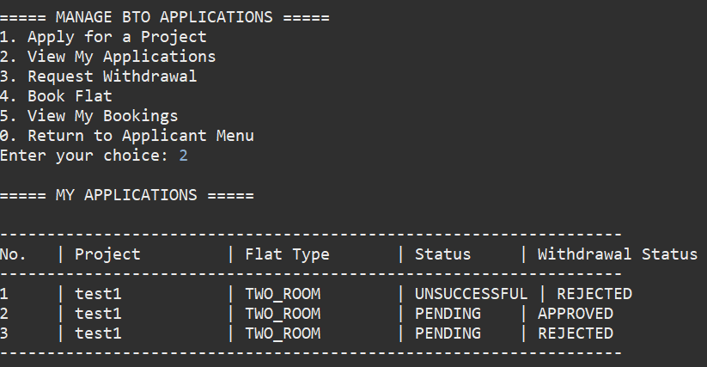

4.23 Generate and Filter Reports
Accurate report generation with options to filter by various categories
